|  |  |
| --- | --- |
| **Ex. No. 9** | **AngularJS Forms and Routing** |
| Date of Exercise: | 17/10/2022 |
| Drive Link: | shorturl.at/vyBM9 |
| GitHub Link: | https://pavitrapati.github.io/urk20cs2017/exp9/exp9.html |

**Aim**

To create webpages for performing form validation and routing using AngularJS.

**Description**

* AngularJS is a superheroic JavaScript Model View Controller(MVC) framework for Web Application Developments. Used to create both client and server-side applications (Full Stack Web Application Development).
* AngularJS offers client-side form validation.
* AngularJS monitors the state of the form and input fields (input, text area, select), and lets you notify the user about the current state.
* AngularJS also holds information about whether they have been touched, or modified, or not.
* The ngRoute module helps your application to become a Single Page Application.
* The ngRoute module routes your application to different pages without reloading the entire application.

**HTML Code**

<!DOCTYPE html>

<html lang="en">

<head>

    <meta charset="UTF-8">

    <meta http-equiv="X-UA-Compatible" content="IE=edge">

    <meta name="viewport" content="width=device-width, initial-scale=1.0">

    <title>Experiment 9</title>

    <!-- CSS only -->

    <link href="https://cdn.jsdelivr.net/npm/bootstrap@5.2.0/dist/css/bootstrap.min.css" rel="stylesheet"

        integrity="sha384-gH2yIJqKdNHPEq0n4Mqa/HGKIhSkIHeL5AyhkYV8i59U5AR6csBvApHHNl/vI1Bx" crossorigin="anonymous">

    <!-- JavaScript Bundle with Popper -->

    <script src="https://cdn.jsdelivr.net/npm/bootstrap@5.2.0/dist/js/bootstrap.bundle.min.js"

        integrity="sha384-A3rJD856KowSb7dwlZdYEkO39Gagi7vIsF0jrRAoQmDKKtQBHUuLZ9AsSv4jD4Xa"

        crossorigin="anonymous"></script>

    <!-- AngularJS CDN -->

    <script src="https://ajax.googleapis.com/ajax/libs/angularjs/1.6.9/angular.min.js"></script>

    <!-- Angular Routing Dependency   -->

    <script src="https://ajax.googleapis.com/ajax/libs/angularjs/1.6.9/angular-route.js"></script>

</head>

<body class="bg-dark text-light" ng-app="myapp" ng-controller="myctrl" style="padding-left: 0px;">

    <h1 class="text-center p-5 text-primary">Form Validation and Routing using Angular JS</h1>

    <hr class="border border-primary border-2 opacity-50">

    <section id="Q1">

        <h3 class="text-center text-white bg mt-5">1. Registration Page</h3>

        <div class="container col-sm-5 mt-5">

            <form name="regForm">

                <label for="t1" class="form-label text-white">Name <span class="text-danger">*</span></label>

                <input type="text" name="name" ng-model="name" id="t1" class="form-control" required>

                <span class="text-danger" ng-show="regForm.name.$invalid && regForm.name.$dirty">Name Required</span>

                <span class="text-danger">{{checkName()}}</span>

                <span class="text-danger">{{nm_error}}</span>

                <br>

                <label for="t2" class="form-label text-white">Password<span class="text-danger">*</span></label>

                <input type="password" id="t2" class="form-control" name="psd" ng-model="psd" required>

                <span class="text-danger" ng-show="regForm.psd.$invalid && regForm.psd.$dirty">Password Required</span>

                <span class="text-danger">{{checkPass()}}</span>

                <span class="text-danger" ng-show="regForm.psd.$valid">{{ps_error}}</span>

                <br>

                <label for="t3" class="form-label text-white">Age <span class="text-danger">*</span></label>

                <input type="text" id="t3" class="form-control" ng-model="age" name="age" required>

                <span class="text-danger" ng-show="regForm.age.$invalid && regForm.age.$dirty">Age Required</span>

                <span class="text-danger">{{checkAge()}}</span>

                <span class="text-danger" ng-show="regForm.age.$valid">{{age_error}}</span>

                <br>

                <label for="t4" class="form-label text-white">Mobile No. <span class="text-danger">*</span></label>

                <input type="tel" id="t4" class="form-control" ng-model="ph" name="ph" required>

                <span class="text-danger" ng-show="regForm.ph.$invalid && regForm.ph.$dirty">Phone No. Required</span>

                <span class="text-danger">{{checkMob()}}</span>

                <span class="text-danger" ng-show="regForm.ph.$valid">{{mob_error}}</span>

                <br>

                <label for="t5" class="form-label text-white">E-Mail <span class="text-danger">*</span></label>

                <input type="email" id="t5" class="form-control" ng-model="em" name="em" required>

                <span class="text-danger" ng-show="regForm.em.$dirty && regForm.em.$error.required">Email

                    Required</span>

                <span class="text-danger" ng-show="regForm.em.$dirty && regForm.em.$error.email">Invalid

                    Email</span><br>

                <label for="male" class="form-label text-white">Gender <span class="text-danger">*</span></label>

                <div>

                    <center>

                        <input class="form-check-input" type="radio" name="gender" ng-model="gender" value="male"

                            id="male">

                        <label class="form-check-label" for="male">

                            Male

                        </label>

                        <input class="form-check-input ms-5" type="radio" name="gender" ng-model="gender" value="fmale"

                            id="fmale">

                        <label class="form-check-label" for="fmale">

                            Female

                        </label>

                        <span class="text-danger">{{checkGender()}}</span>

                        <span class="text-danger ps-4">{{gen_error}}</span>

                    </center>

                </div> <br>

                <label for="state" class="form-label text-white">State <span class="text-danger">*</span></label>

                <select class="form-select" id="state" aria-label="Default select example" ng-model="state">

                    <option value="1">Tamil Nadu</option>

                    <option value="2">kerala</option>

                    <option value="3">Karnataka</option>

                    <option value="3">Andhra Pradhesh</option>

                </select>

                <span class="text-danger">{{checkState()}}</span>

                <span class="text-danger">{{st_error}}</span>

            </form>

            <div class="text-center mb-4">

                <button

                    ng-disabled="nm_error!='' || regForm.name.$invalid || regForm.psd.$invalid || ps_error!='' || regForm.age.$invalid || age_error!='' || myform.ph.$invalid || mob_error!='' || myform.em.$invalid || gen_error!='' || st_error!='' "

                    class="btn btn-outline-primary mt-5">Submit</button>

            </div>

        </div>

        <hr class="border border-primary border-2 opacity-50">

    </section>

    <section id="Q2" ng-app="calc">

        <h3 class="text-center text-white bg mt-5">2.Routing</h3>

        <div class="container col-sm-8 mt-5">

            <center>

                <div class="text-center col-sm-6 mt-5">

                    <a class="text-success" href="#!page1">URK20CS1158</a>

                    <a class="text-success" href="#!page2">URK20CS3006</a>

                    <a class="text-success" href="#!page3">URK20CS3001</a>

                    <a class="text-success" href="#!page4">URK20CS2069</a>

                </div>

            </center>

            <div ng-view class="mt-3">

            </div>

        </div>

        <hr class="border border-primary border-2 opacity-50">

    </section>

    <script src="index.js"></script>

</body>

</html>

**Main.html**

<!DOCTYPE html>

<html lang="en">

<head>

    <meta charset="UTF-8">

    <meta http-equiv="X-UA-Compatible" content="IE=edge">

    <meta name="viewport" content="width=device-width, initial-scale=1.0">

    <script src="https://ajax.googleapis.com/ajax/libs/angularjs/1.0.7/angular.min.js"></script>

    <script src="https://ajax.googleapis.com/ajax/libs/angularjs/1.6.9/angular-route.js"></script>

    <script type="text/javascript" src="script.js"></script>

    <link rel="stylesheet" type="text/css" href="style.css">

    <link rel="preconnect" href="https://fonts.gstatic.com">

    <link

        href="https://fonts.googleapis.com/css2?family=Josefin+Sans:ital,wght@0,100;0,200;0,300;0,400;0,500;0,600;0,700;1,100;1,200;1,300;1,400;1,500;1,600;1,700&display=swap"

        rel="stylesheet">

    <link rel="stylesheet" href="https://cdnjs.cloudflare.com/ajax/libs/font-awesome/5.15.3/css/all.min.css"

        integrity="sha512-iBBXm8fW90+nuLcSKlbmrPcLa0OT92xO1BIsZ+ywDWZCvqsWgccV3gFoRBv0z+8dLJgyAHIhR35VZc2oM/gI1w=="

        crossorigin="anonymous" referrerpolicy="no-referrer" />

    <script src="https://ajax.googleapis.com/ajax/libs/jquery/3.6.0/jquery.min.js"></script>

    <title>Experiment_9</title>

    <style>

        body {

            padding-left: 15%;

        }

        .profiles1 {

            display: flexbox;

            width: 10%;

            border: 5px;

            border-style: groove;

            border-radius: 10px;

        }

        .profiles {

            display: inline-flex;

            width: 10%;

            border: 5px;

            border-style: groove;

            border-radius: 10px;

        }

        .resume {

            display: flexbox;

            width: 90%;

            border: 5px;

            border-style: groove;

            border-radius: 10px;

        }

    </style>

</head>

<body ng-app="myapp">

    <div style="background-color: black; ">

        <nav style="position: sticky;top: 0;z-index: 2;background-color: rgb(0,0,0,0.5);">

            <h2 class="logo">Resu<span>me</span></h2>

            <ul>

                <li><a href="#hero">Home</a></li>

                <li><a href="#about">About Me</a></li>

                <li><a href="#service">Certifications</a></li>

                <li><a href="#Skills">Skills</a></li>

                <li><a href="#footer">Contact</a></li>

            </ul>

            <a href="#" class="btn">Join Me!</a>

        </nav>

        <div class="hero" id="hero">

            <div class="content">

                <h4>Hello, my name is</h4>

                <h1>Pavitra <span>KITSUNE<br>Pati</span></h1>

                <h3>I'am an AI Enthusiast.</h3>

                <div class="newslatter">

                    <form>

                        <input type="email" name="email" id="mail" placeholder="Enter Your Email">

                        <input type="submit" name="submit" value="Lets Start">

                    </form>

                </div>

            </div>

        </div>

        <!----About section start---->

        <section class="about" id="about">

            <div class="main">

                <img src="main-img.jpg">

                <div class="about-text">

                    <h2>About Me</h2>

                    <h5>Programmer <span>& Ethical Hacker</span></h5>

                    <p>I am a proficient python programmer. I have knowledge in basic linux coding and ethical

                        hacking

                        using

                        kali linux. I also code ML & DL models that produce the best accuracy in their fields. I

                        have

                        Proficiency in Data Science techniques to improve the accuracy of the models that i build.

                    </p>

                    <button type="button">Let's Talk</button>

                </div>

            </div>

        </section>

        <!-----service section start----------->

        <div class="service" id="Skills">

            <div class="title">

                <h2>Skills</h2>

            </div>

            <div class="box">

                <div class="card">

                    <i><img src="python.png" class="icon"></i>

                    <h5>Python</h5>

                    <div class="pra"><br><br>

                        <progress class="pb" value="85" max="100"></progress>

                    </div>

                </div>

                <div class="card">

                    <i><img src="html.png" class="icon"></i>

                    <h5>Html & CSS & JavaScript</h5>

                    <div class="pra"><br>

                        <progress class="pb" value="60" max="100"></progress>

                    </div>

                </div>

                <div class="card">

                    <i><img src="linux.png" class="icon"></i>

                    <h5>Linux - Kali Linux</h5>

                    <div class="pra"><br><br>

                        <progress class="pb" value="50" max="100"></progress>

                    </div>

                </div>

                <div class="card">

                    <i><img src="java.png" class="icon"></i>

                    <h5>Java</h5>

                    <div class="pra"><br><br>

                        <progress class="pb" value="60" max="100"></progress>

                    </div>

                </div>

            </div>

        </div>

        <!--Skills-->

        <div class="service" id="service">

            <div class="title">

                <h2>My Certifications and Internships</h2>

            </div>

            <div class="box">

                <div class="card">

                    <i><img src="edx.png" class="icon"></i>

                    <h5>AI for everyone: Master the basics</h5>

                    <div class="pra">

                        <p>Certification on AI basics in edx<br><br><br></p>

                        <p style="text-align: center;">

                            <a class="button" target="_blank"

                                href="https://courses.edx.org/certificates/2de4578e30be4bb0b30d9bd3d7dc8e82">Certificate</a>

                        </p>

                    </div>

                </div>

                <div class="card">

                    <i><img src="coursera.png" class="icon"></i>

                    <h5>Python Basics</h5>

                    <div class="pra">

                        <p>Mastered all the basics in python through this certifications from university of

                            michigan<br><br>

                        </p>

                        <p style="text-align: center;">

                            <a class="button" target="_blank"

                                href="https://coursera.org/share/ed4a6ab1ca7cfb9da80d44c2d6f8be61">Certificate</a>

                        </p>

                    </div>

                </div>

                <div class="card">

                    <i><img src="kaggle.png" class="icon"></i>

                    <h5>Intro to Deep Learning</h5>

                    <div class="pra">

                        <p>Used TensorFlow and Keras to build and train neural networks for structured data.<br><br>

                        </p>

                        <p style="text-align: center;">

                            <a class="button" target="_blank"

                                href="https://cdn.discordapp.com/attachments/894978734686343208/1028680784875360256/Sankineni_Prabhu_Gopal_Vamshi_-_Intro_to_Deep_Learning.png">Certificate</a>

                        </p>

                    </div>

                </div>

                <div class="card">

                    <i><img src="kaggle.png" class="icon"></i>

                    <h5>Intro to Machine Learning</h5>

                    <div class="pra">

                        <p>Learned the core ideas in machine learning, and have built many of my models.<br></p>

                        <p style="text-align: center;">

                            <a class="button" target="_blank"

                                href="https://cdn.discordapp.com/attachments/894978734686343208/1028680785844252692/Sankineni_Prabhu_Gopal_Vamshi_-_Intro_to_Machine_Learning_1.png">Certificate</a>

                        </p>

                    </div>

                </div>

                <div class="card">

                    <i><img src="kaggle.png" class="icon"></i>

                    <h5>Data Visualization</h5>

                    <div class="pra">

                        <p>I have visualized many data and felt the power of coding.<br><br></p>

                        <p style="text-align: center;">

                            <a class="button" target="_blank"

                                href="https://cdn.discordapp.com/attachments/894978734686343208/1028680785231884369/Sankineni_Prabhu_Gopal_Vamshi_-_Data_Visualization_1.png">Certificate</a>

                        </p>

                    </div>

                </div>

                <div class="card">

                    <i><img src="kaggle.png" class="icon"></i>

                    <h5>Computer Vision</h5>

                    <div class="pra">

                        <p>I have built many convolutional neural networks with TensorFlow and Keras.<br></p>

                        <p style="text-align: center;">

                            <a class="button" target="_blank"

                                href="https://cdn.discordapp.com/attachments/894978734686343208/1028680784489484308/Sankineni_Prabhu_Gopal_Vamshi_-_Computer_Vision.png">Certificate</a>

                        </p>

                    </div>

                </div>

            </div>

        </div>

        <!------Contact Me------>

        <div class="contact-me">

            <p>Let Me build you a model</p>

            <a class="button-two" href="#">Hire Me</a>

        </div>

        <!------footer start--------->

        <footer id="footer">

            <p> Pavitra Pati </p>

            <p>Reach me:</p>

            <div class="social">

                <a href="https://discord.gg/ZCd5W2ed" target="_blank"><i class="fab fa-discord"></i></a>

                <a href="https://instagram.com/pavitraxdr/" target="_blank"><i class="fab fa-instagram"></i></a>

                <a href="#" target="_blank"><i class="fab fa-dribbble"></i></a>

            </div>

            <p class="end">CopyRight By Pavitra Pati</p>

        </footer>

    </div>

</body>

</html>

**Index.js**

var app = angular.module("myapp", ["ngRoute"]);

app.controller("myctrl", ($scope) => {

    $scope.checkGender = () => {

        if ($scope.gender === undefined) {

            $scope.gen_error = "Gender is required"

        }

        else {

            $scope.gen_error = ""

        }

    }

    $scope.checkState = () => {

        if ($scope.state === undefined) {

            $scope.st_error = "Select State"

        }

        else {

            $scope.st_error = ""

        }

    }

    $scope.checkName = function () {

        if (/\d/.test($scope.name)) {

            $scope.nm_error = "Name can't have numbers"

        }

        else {

            $scope.nm_error = ""

        }

    }

    $scope.checkPass = function () {

        if (/[a-z]/.test($scope.psd) && /[A-Z]/.test($scope.psd) && /\d/.test($scope.psd) && $scope.psd.length > 7) {

            $scope.ps_error = ""

        }

        else {

            $scope.ps_error = "Password Must Contain atleast 1 uppercase, 1 lowercase, a number and 8 characters"

        }

    }

    $scope.checkAge = function () {

        if ($scope.age >= 18 && $scope.age <= 30) {

            $scope.age_error = ""

        }

        else {

            $scope.age_error = "Age must be within 18 to 30"

        }

    }

    $scope.checkMob = function () {

        if ($scope.ph != undefined && $scope.ph.length === 10) {

            $scope.mob_error = ""

        }

        else {

            $scope.mob_error = "Mobile No must have 10 digits"

        }

    }

})

app.config(function ($routeProvider) {

    $routeProvider.when('/page1', {

        templateUrl: './profile1.html'

    })

        .when('/page2', {

            templateUrl: './profile2.html'

        })

        .when('/page3', {

            templateUrl: './profile3.html'

        })

        .when('/page4', {

            templateUrl: './profile4.html'

        })

        .otherwise({ redirectTo: '/page1' })

})

**OUTPUT**

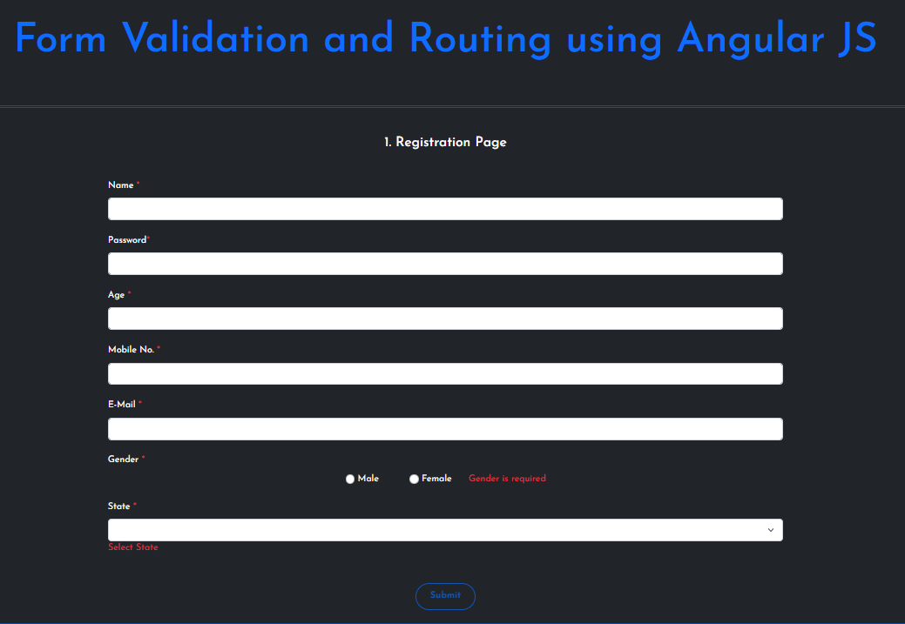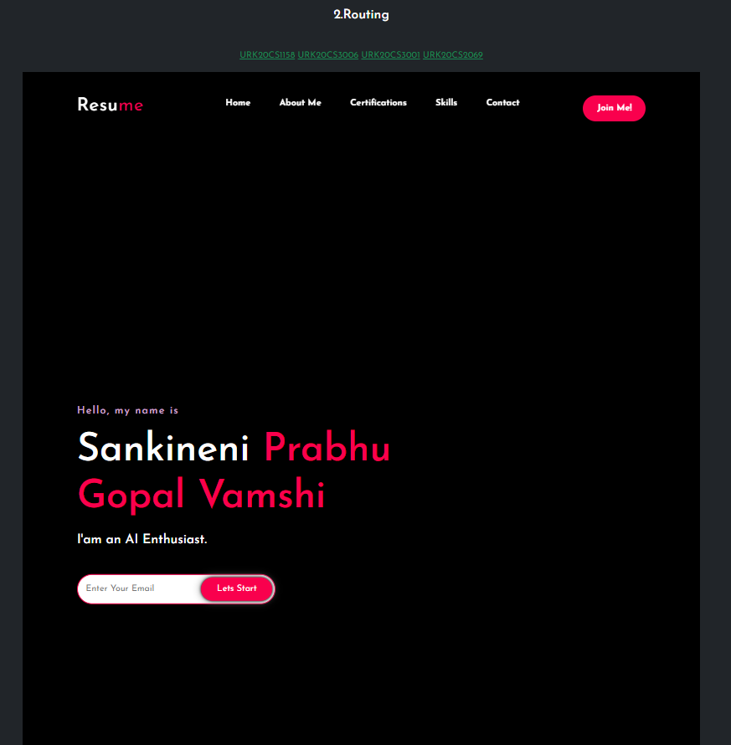

**RESULT**

The form validation and routing were successfully done using AngularJS.